Special Camp in the Adopted Village
Day 1 : programme on Dowry system, child Marriage and cleanliness

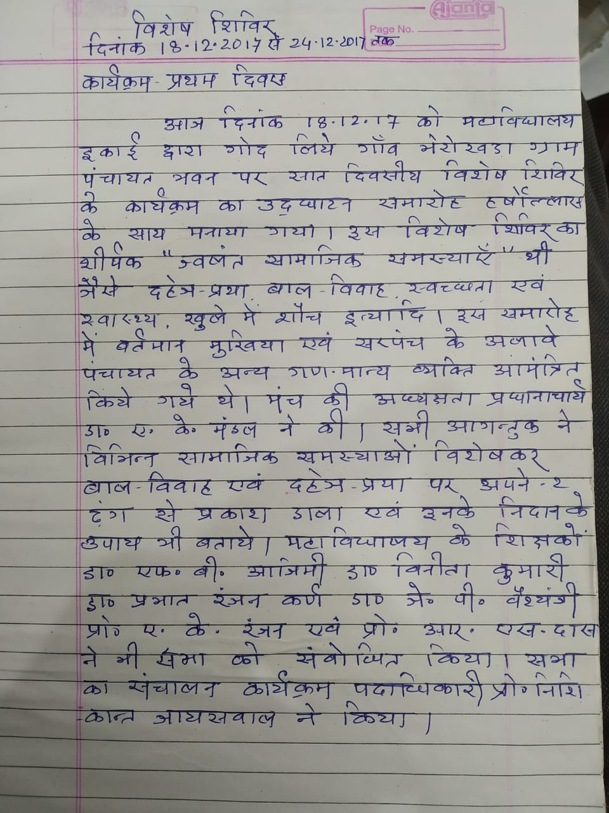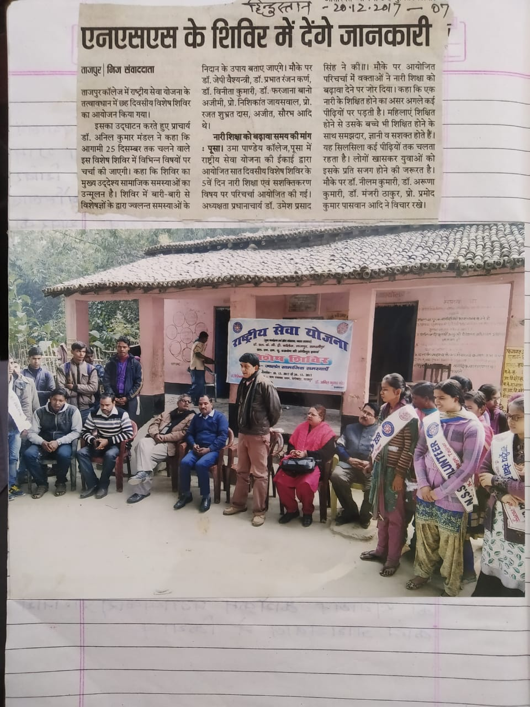
Media report published on daily Newspaper Hindustan
Day 2: Programme on Different problems of the village
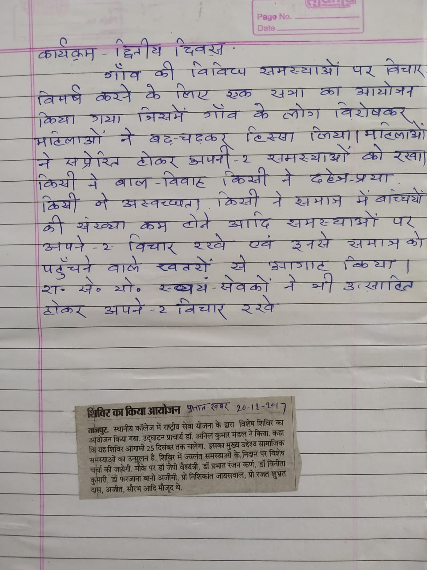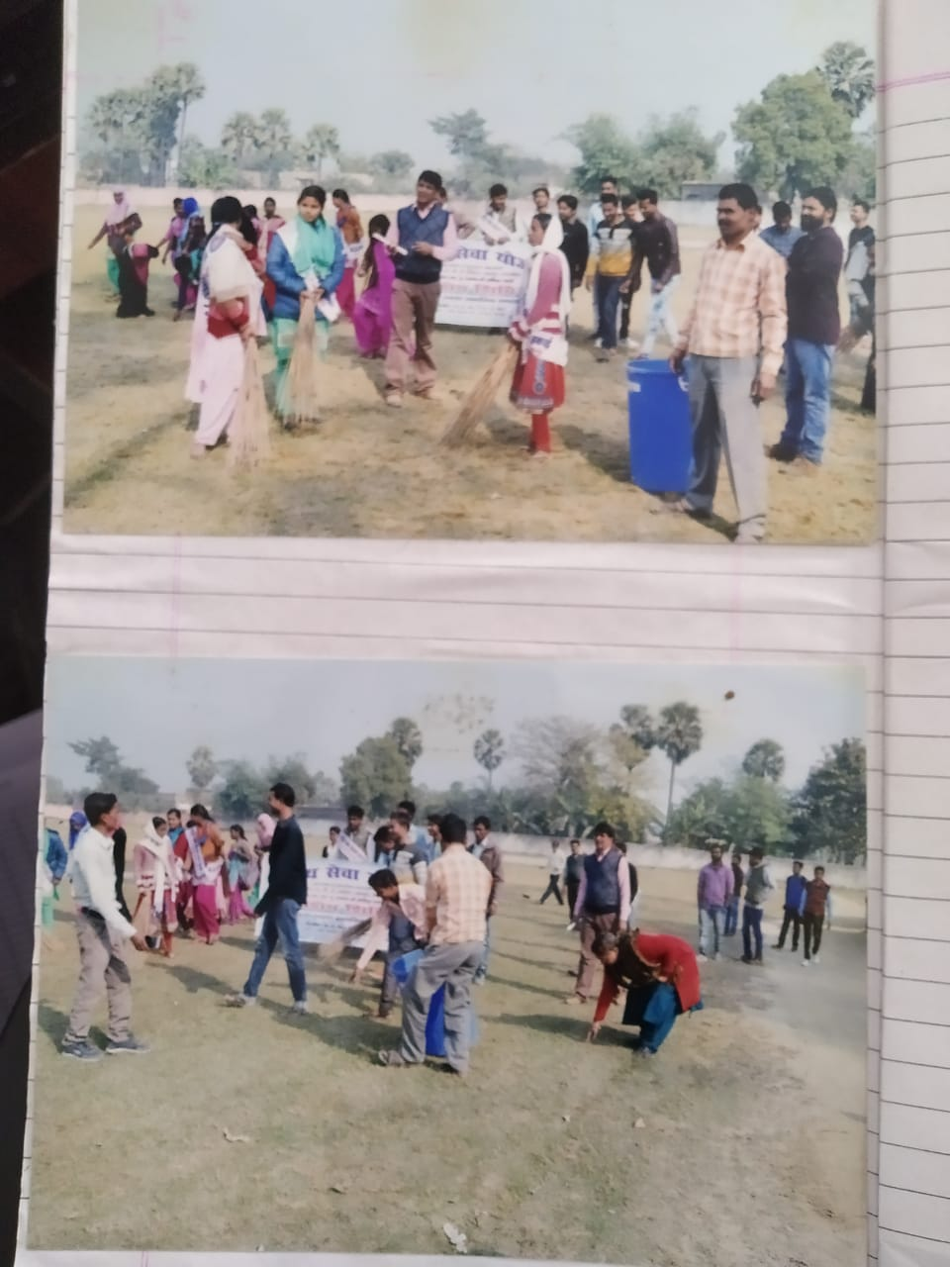
Report of the event published in the daily Newspaper Prabhat Khabar
Day 4 : Programme on Education for all Day 3 : Rally on dowry system and child marriage
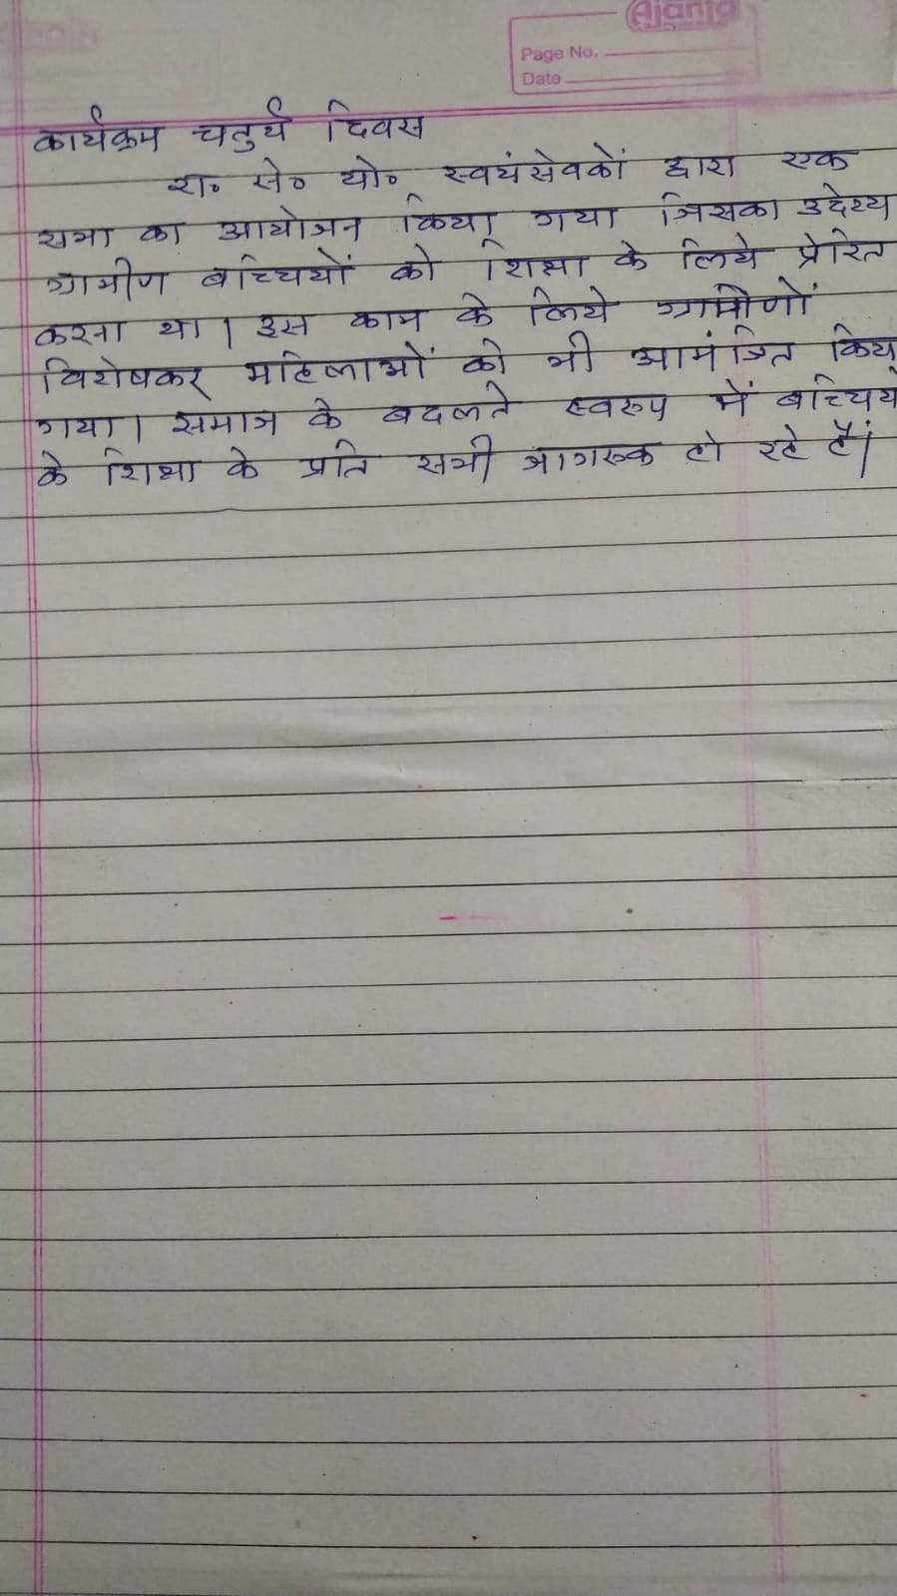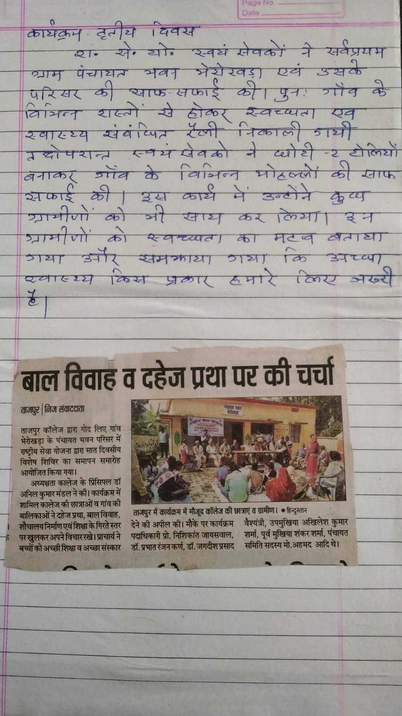
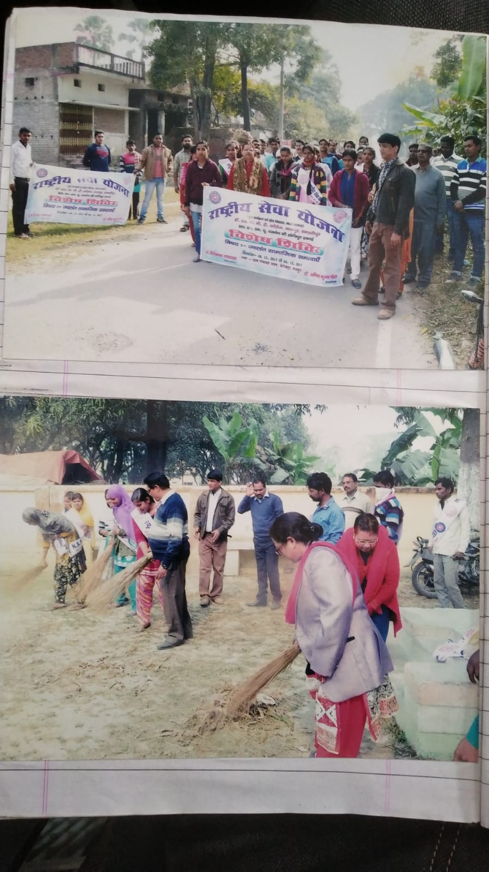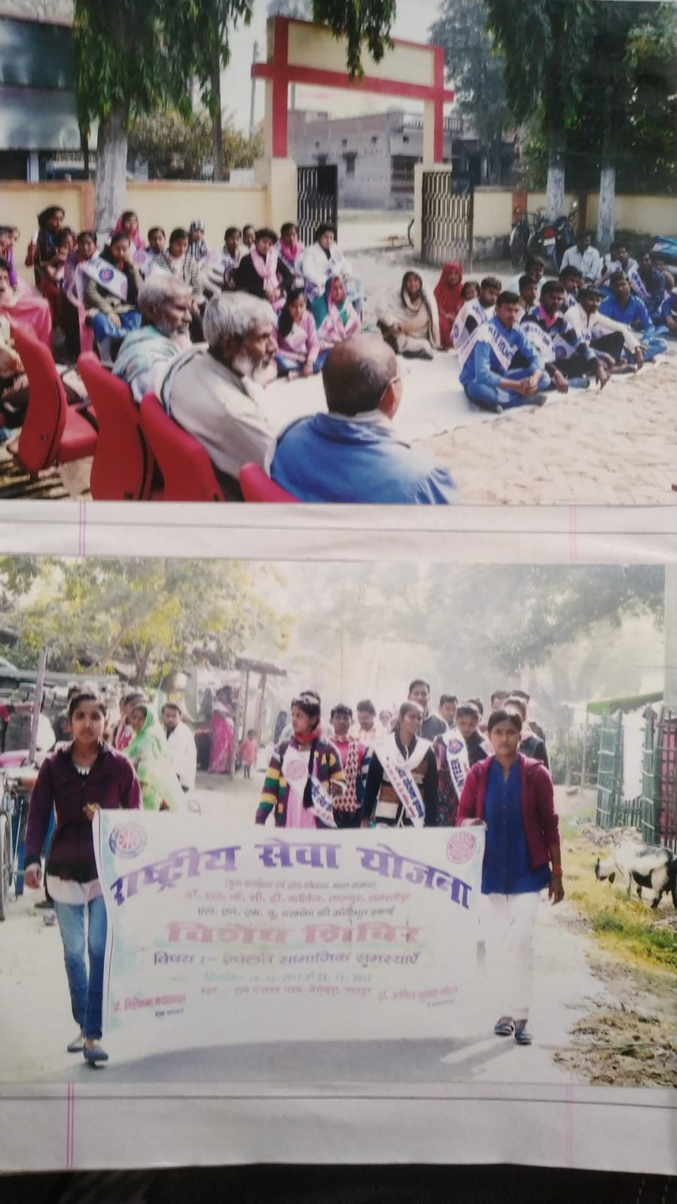
Media report published in daily Newspaper Hindustan

Day 6: Awareness Programme on dropout of student. Day 5: Cleanliness Rally
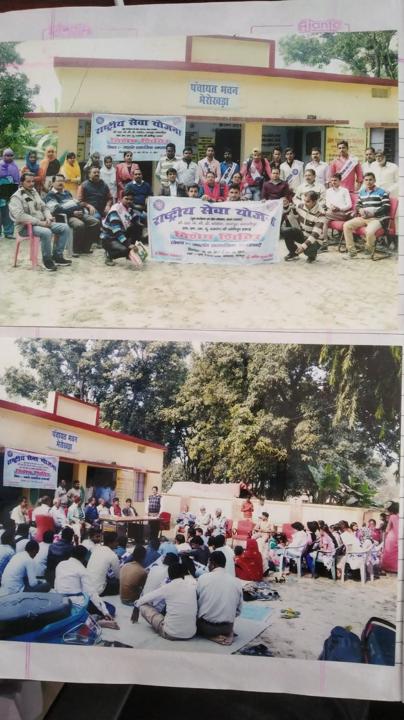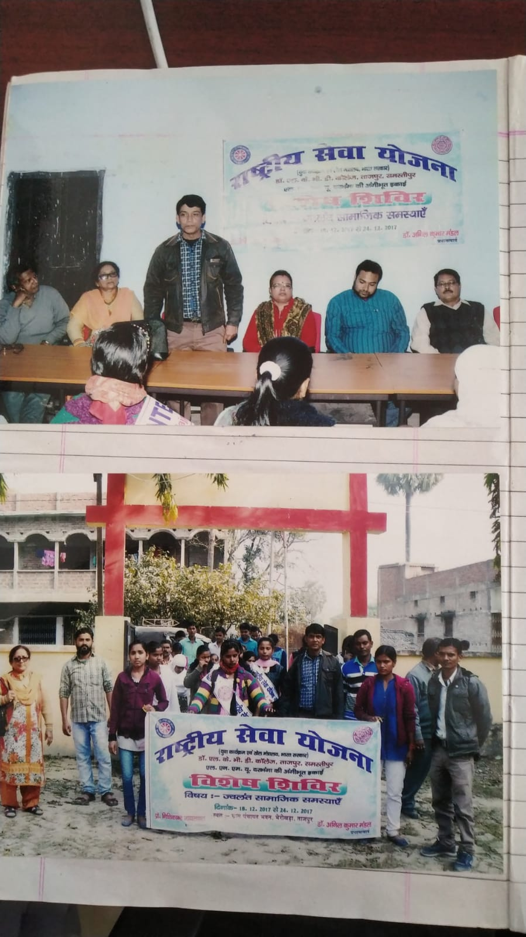
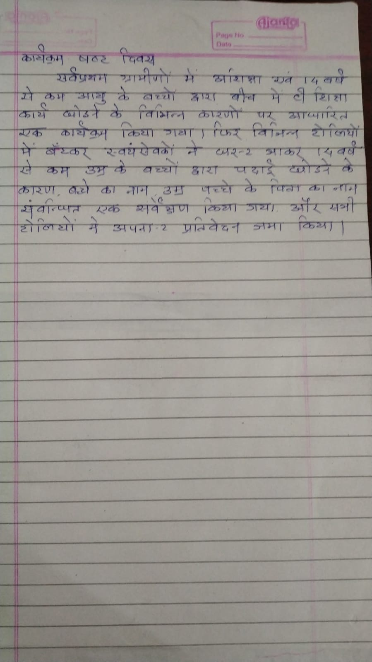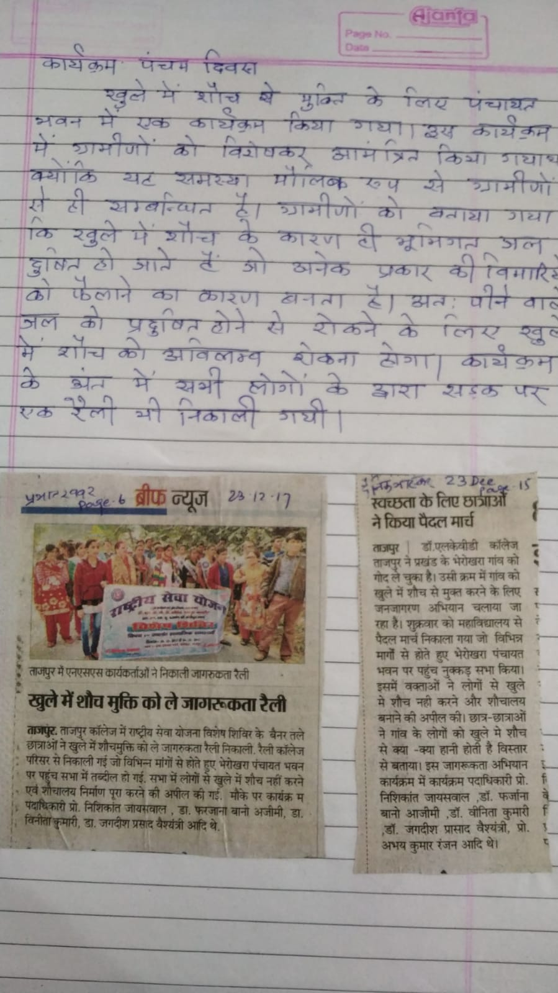
Media reports published in daily Newspaper Prabhat Khabar and Dainik Bhaskar.

Day 7 : Interaction with local People.
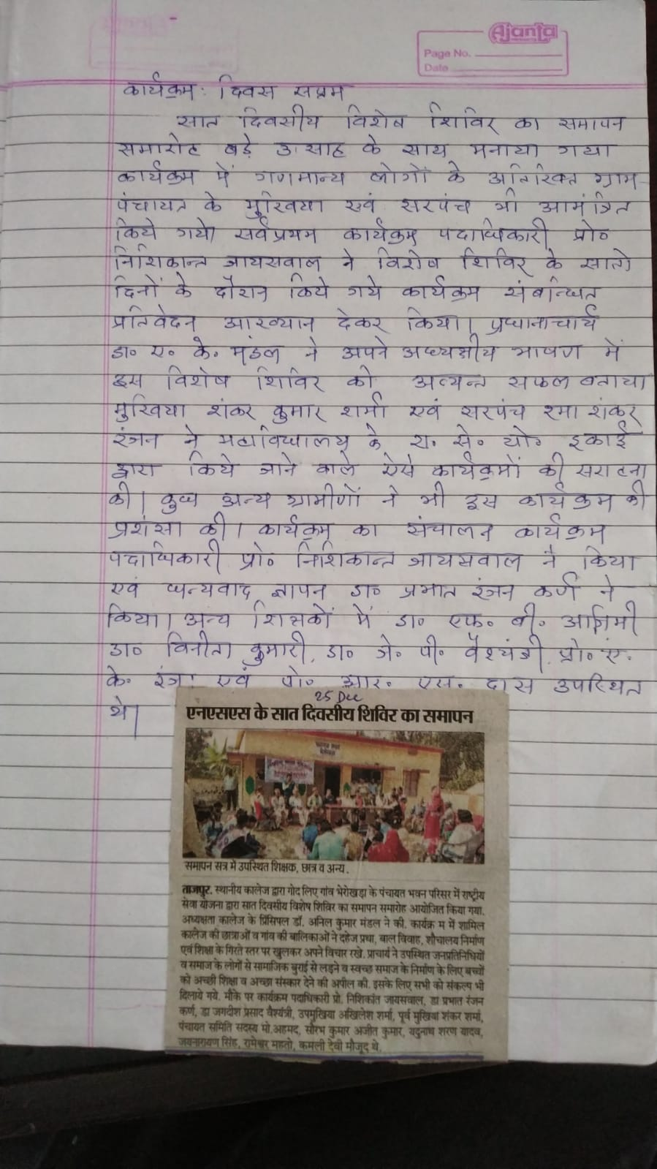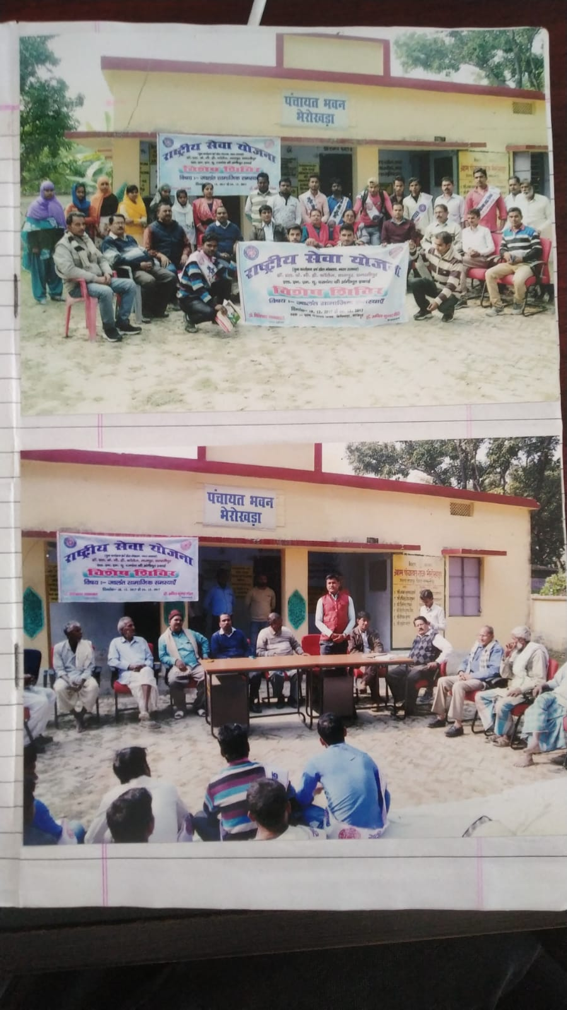
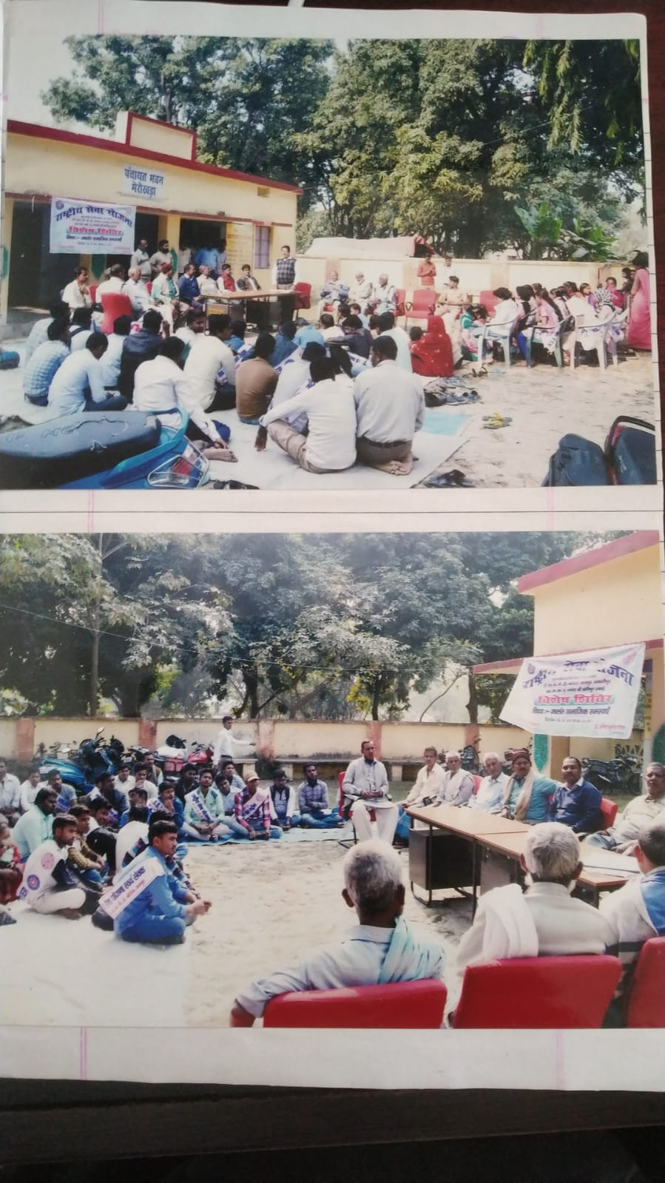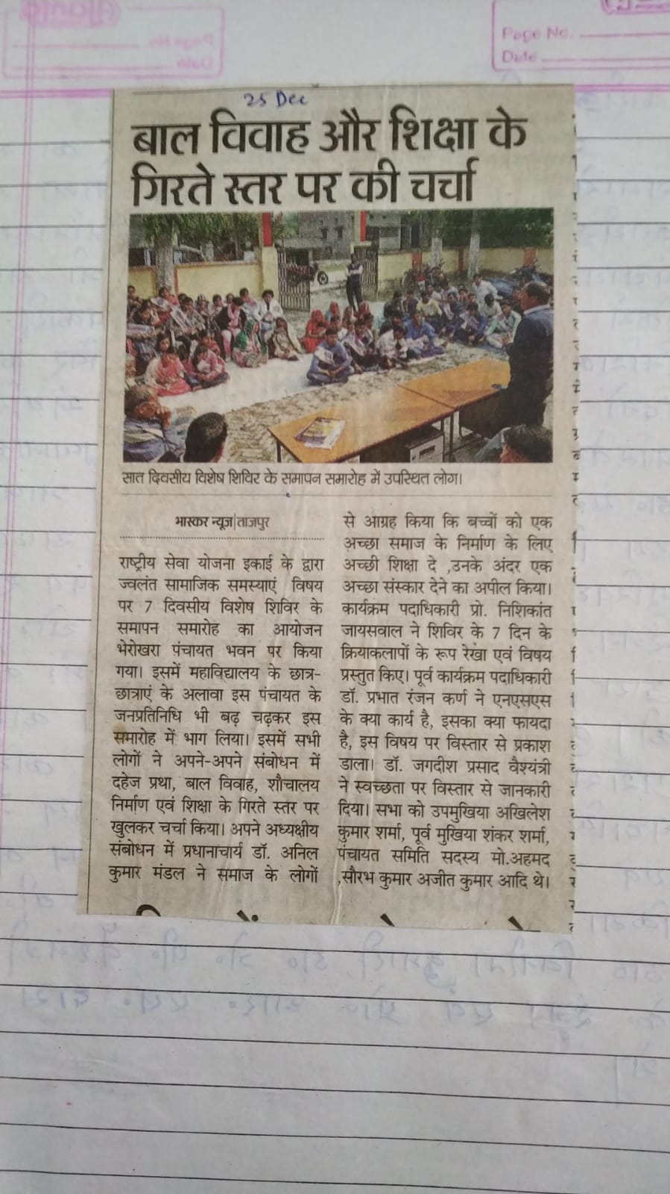
Media report published in daily Newspaper Prabhat Khabar and Dainik Bhaskar.

